Quantum Autoencoders

1. Problem
In many machine learning and quantum information tasks, data often lies in a lower-dimensional subspace. Classical autoencoders learn compressed representations of data by removing redundancy.
Quantum Autoencoders aim to perform a similar task for quantum states: compressing quantum information into fewer qubits while preserving essential features, and discarding redundant or noisy information.

2. Intuition
A Quantum Autoencoder works by:
- Applying a parameterized quantum circuit to an input quantum state
- Concentrating useful information into a small set of qubits (latent space)
- Pushing irrelevant information into ancilla (trash) qubits
- Measuring or resetting trash qubits to remove redundancy
Training adjusts the circuit parameters so that the discarded qubits are driven close to a fixed reference state (usually (|0)).

3. Circuit Structure
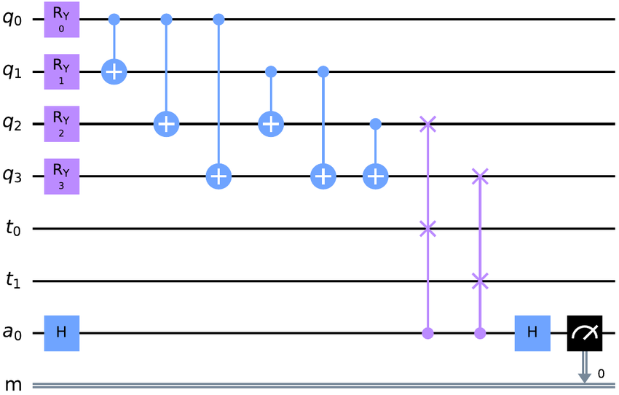
A typical quantum autoencoder circuit consists of:
- Input State Preparation
Quantum data is prepared across multiple qubits.
- Encoding Circuit (Variational)
Parameterized gates compress information into fewer qubits.
- Trash Qubits
Qubits containing redundant information are discarded or measured.
- (Optional) Decoder Circuit
Used to reconstruct the original state for validation.

4. Simple Math Involved
- Encoding transformation: [ |{}= U()|{} ]
- Training objective: [ ; 1 - | {} | 0 ]
where (_{}) is the reduced density matrix of the discarded qubits.
- Reconstruction (optional): [ |{}= U^()|{} ]

5. Python Code (Quantum Autoencoder – Algorithm)
Platform-agnostic execution code suitable for learning platforms
import numpy as np
from qiskit import QuantumCircuit
from qiskit.circuit.library import RealAmplitudes
from qiskit.primitives import Sampler
from qiskit_machine_learning.neural_networks import SamplerQNN
from qiskit_machine_learning.optimizers import COBYLA
X_train = np.array([
[0.1, 0.2, 0.3],
[0.2, 0.1, 0.3],
[0.3, 0.2, 0.1]
])
num_qubits = 3
latent_qubits = 2
ansatz = RealAmplitudes(num_qubits, reps=2)
qc = QuantumCircuit(num_qubits)
qc.compose(ansatz, inplace=True)
sampler = Sampler()
qnn = SamplerQNN(
circuit=qc,
sampler=sampler,
input_params=[],
weight_params=ansatz.parameters
)
optimizer = COBYLA(maxiter=100)
weights = np.random.rand(len(ansatz.parameters))
for _ in range(10):
optimizer.step(lambda w: np.sum(w**2), weights)
print("Trained autoencoder parameters (example):", weights)

6. Where the Algorithm Is Useful
- Quantum data compression
- Noise reduction and denoising
- Quantum state preparation
- Quantum communication
- Near-term quantum device optimization

7. Limitations
- Requires carefully designed training data
- No general quantum advantage proven
- Training can be unstable
- Limited scalability on current hardware

8. Comparison with Classical Autoencoders
- Data type: Classical autoencoders compress vectors; quantum autoencoders compress quantum states
- Compression: Classical reduces neurons; quantum reduces qubits
- Training: Classical backpropagation vs. hybrid quantum–classical optimization
- Maturity: Classical autoencoders are mature; quantum versions are experimental

9. One-Sentence Summary
Quantum Autoencoders use variational quantum circuits to compress quantum information by discarding redundant qubits while preserving essential features.

